https://beebom.com/best-latex-editors/:
8 Best LaTeX Editors (beebom.com)
 | Srikanth AN - Last Updated: January 9, 2018 7:11 pm
Handling digital documents have become a part of the daily lives of users and almost everyone is familiar with Microsoft Word. We have seen a lot of Document editing tools and most of them follow the WYSIWYG (‘What you see is what you get’) approach to Word formatting. In such type of Word formatting, a GUI based approach is established and users can visualise the end result while typing out content. That is one way of approaching Word Formatting. Another way is through the use of a Word formatting tool that makes use of the WYSIWYM (‘What you see is what you mean’) approach. Here, the word formatting is done as a markup entry beforehand and then content is added to it later.
Contents
What is a LaTeX editor? 1
8 Best LaTeX editors 2
1. TeXmaker 2
Key Features 3
Platforms Supported 3
2. TeXstudio 3
Key Features 4
Platforms Supported 4
3. TeXworks 4
Key Features 5
Platforms Supported 5
Best online LaTeX editors 5
Heading 1 5
Heading 2 5
Heading 3 5

What is a LaTeX editor?
Still don’t get what this is all about? In simple terms, LaTeX (spelled Lay-tek), is a markup level text editing tool that separates the word formatting from the content entry task. Quite similar to HTML in its formatting, LaTeX is one of the most commonly used text editor in the academia. For people having to deal with scientific papers and publishing, with a lot of mathematical equations thrown into the mix, LaTeX text editors are quite the industry standards. These tools allow users to define formatting of text before hand through markup-level instructions and once the content is inserted, the document is ready to be exported as a PDF or any other file format. Mathematical equations are exceptionally handled by these editors and they were the primary reasons leading to its development in the first place.

8 Best LaTeX editors
Now that you’ve understood what exactly is the primary purpose of a LaTeX Text editor and how it differs from regular GUI-Based editors, we will be taking a look at some of the best LaTeX tools. So, here are the Best 8 LaTeX editors that will ever need.

1. TeXmaker
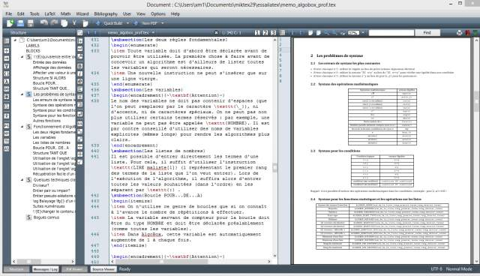
TeXmaker is one of the most popular open-source, multi-platform solution to LaTeX editing. This tool is available for all major platforms and possesses features that make a great case for any LaTeX text editor. To get started with TeXmaker, its configuration window allows users to set-up all the basic settings of their LaTeX document before starting work on it. TeXmaker also allows users to set-up the spell-checking and other document layout settings through the ‘Quick start’ window. The ‘Structure View‘ allows users to streamline their documents into separate sections, labeling each one in the process. Inserting Tables, Math formulae, cross-references, pictures, etc is pretty straightforward with TeXmaker.
Once the groundwork of your document layout is set up using TeXmaker, the document can now be compiled to get it extracted as a PDF, HTML or ODF file format. Another key feature of TeXmaker is the way it allows users to track errors during the compilation stage. All warnings and errors are displayed to let the user take the needed action regarding the same. Parts/sections of your documents could be easily folded/unfolded using TeXmaker. This tool is also great for creating a structured Bibliography section of your document. Keyboard short-cuts are abundant for TeXmaker and it makes the overall experience with this tool pretty worthwhile.

Key Features
Unicode support, Code folding, Spell-checking, Built-in PDF viewer, Auto-completion, 370 mathematical symbols and more.

Platforms Supported
Windows, Mac OS X and Linux
Visit Website

2. TeXstudio
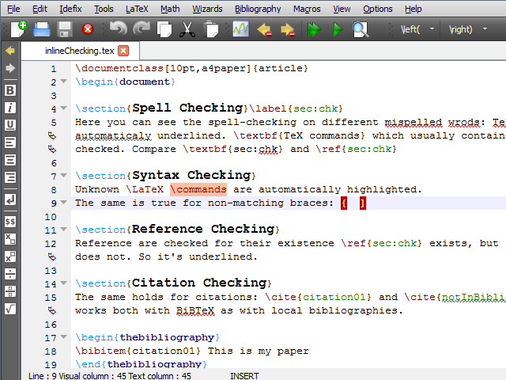
TeXstudio is another open-source and multi-platform LaTeX editor, which is quite popular among the academia. This tool is based on the open-source TeXmaker which we just talked about. TeXstudio is pretty much an extension of the former mentioned tool and added further support and features to it. While the entire interface might pretty much feel similar to TeXmaker, but additional features like Document Word count, frequency count analysis and more made it into an independent full-blown LaTeX editing tool itself.
Some of its key features are Syntax Highlighting, reference checking, multi-cursors and more than 1000 mathematical formulae included with it. Citations form a major component of scientific documents and TeXstudio provides support for Link overlay, that converts text into links. The Assistant feature of TeXstudio makes it easy for anyone without the complete knowledge of LaTeX editors set up a file and place blocks of images or tables anywhere in the document. Images could be dragged and dropped into this editor and Table Auto-formatter takes care of adequately formatting your created tables. These are the additional features to TeXstudio, in addition to the regular Structure viewing, Code folding, Spell-checking, Auto-corrections, Syntax highlighting and all the other features that TeXmaker possesses.

Key Features
Auto-completion, Insertion of Tables, Figures, Mathematical formulae, Spell-checking, Built-in PDF viewer, Syntax highlighting, Export to HTML and more.

Platforms Supported
Windows, Mac OS X, Linux and FreeBSD.
Visit Website

3. TeXworks
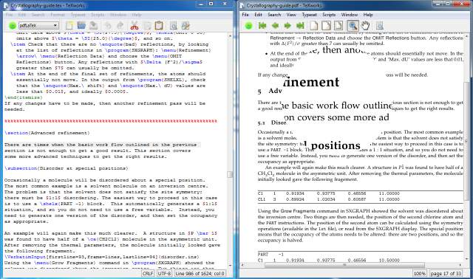
TeXworks is another multi-platform, open-source LaTeX editor. TeXworks is a LaTeX editing tool that is based off another open-source LaTeX editor – TeXshop. It provides a GUI-based approach to LaTeX editing and features many of the key advantages found in the previous mentioned tools. TeXworks features a built-in PDF viewer just like in the above mentioned tools, but this tool also possesses an auto-synchronisation feature to it.
TeXworks features many of the key capabilities of a LaTeX editor like auto-completion, auto-correction, Unicode support and more. If only the basic bare bones of a LaTeX editor is required, It ticks in all the boxes perfectly. This tool although does not feature many of the key features, its minimalistic approach to LaTeX editing gets the work done without fussing much about its functionalities. Code folding, Insertion of graphics/tables, interaction with external editors and its powerful built-in PDF viewer and exporter makes this tool one of the best LaTeX editors that the academia often tend to consider.

Key Features
Code folding, auto-completion, auto-correction, Unicode support and built-in PDF viewer.

Platforms Supported
Windows, Mac OS X and Linux
Visit Website

Best online LaTeX editors

Heading 1

Heading 2

Heading 3

